CS 255 Business Requirements Document Template

Complete this template by replacing the bracketed text with the relevant information.

This template lays out all the different sections that you need to complete for Project One. Each section has guiding questions to prompt your thinking. These questions are meant to guide your initial responses to each area. You are encouraged to go beyond these questions using what you have learned in your readings. You will need to continually reference the interview transcript as you work to make sure that you are addressing your client’s needs. There is no required length for the final document. Instead, the goal is to complete each section based on your client’s needs.

Tip: You should respond in a bulleted list for each section. This will make your thoughts easier to reference when you move into the design phase for Project Two. One starter bullet has been provided for you in each section, but you will need to add more.

System Components and Design

Purpose
What is the purpose of this project? Who is the client and what do they want their system to be able to do?

- The purpose of this project is to design an online and administrative system for DriverPass, a company that provides students with online driver education, practice exams, and on-the-road driving lessons.
- The system will allow students to register, schedule driving lessons, access online study materials, and take practice exams.
- It will allow administrative staff to manage appointments, packages, drivers, cars, and student data.
- IT administrators will have control over user roles, account access, and system maintenance.

System Background
What does DriverPass want the system to do? What is the problem they want to fix? What are the different components needed for this system?

- DriverPass identified that over 65% of new drivers fail DMV exams due to lack of practical and online preparation.
- The company’s goal is to offer a web-based solution that integrates classroom and on-road training with DMV-compliant materials.
- The current problem: no centralized platform to schedule lessons, track progress, or manage packages.
- The new system must include:
  - User accounts with roles and permissions.
  - Online class and test modules.
  - Scheduling and reservation system for driving lessons.
  - Database for customer, driver, and vehicle information.
  - Tracking and reporting for user activity and performance.

Objectives and Goals
What should this system be able to do when it is completed? What measurable tasks need to be included in the system design to achieve this?
- Enable users to register and log in securely.
- Allow students to schedule, modify, or cancel lessons online.
- Provide online classes, DMV practice tests, and progress tracking.
- Allow administrators to view, approve, and modify appointments.
- Allow IT admin to manage accounts, reset passwords, and restrict access when necessary.
- Ensure the system syncs with DMV data for updated policies and test content.
- Provide reporting and tracking for lesson reservations, cancellations, and updates.

Requirements

Nonfunctional Requirements
In this section, you will detail the different nonfunctional requirements for the DriverPass system. You will need to think about the different things that the system needs to function properly.

Performance Requirements
What environments (web-based, application, etc.) does this system need to run in? How fast should the system run? How often should the system be updated?

- The system shall be web-based, accessible via browser on desktop and mobile.
- Pages should load within 3 seconds under normal conditions.
- System updates shall occur monthly or as required by DMV changes.
- The system must support concurrent access by multiple users.

Platform Constraints
What platforms (Windows, Unix, etc.) should the system run on? Does the back end require any tools, such as a database, to support this application?

- The system shall operate on Windows, macOS, and mobile browsers using a cloud-hosted web application.
- Backend shall use a secure database (SQL or similar).
- Cloud hosting will manage backup, storage, and scalability.

Accuracy and Precision
How will you distinguish between different users? Is the input case-sensitive? When should the system inform the admin of a problem?

- The system shall distinguish users by unique credentials (username/password).
- All user input will be validated for completeness and accuracy.
- The system shall notify the administrator of any login failures or account lockouts.
- Activity logs must identify the user, date, and change type for each update.

Adaptability
Can you make changes to the user (add/remove/modify) without changing code? How will the system adapt to platform updates? What type of access does the IT admin need?

- Admins shall be able to add, modify, or disable training packages without changing source code.
- The system must handle software or platform updates without disrupting data.
- IT administrators shall have full access to manage accounts, permissions, and backups.

Security
What is required for the user to log in? How can you secure the connection or the data exchange between the client and the server? What should happen to the account if there is a “brute force” hacking attempt? What happens if the user forgets their password?

- All users must log in with valid credentials.
- Passwords shall be stored using secure encryption.
- The system shall lock accounts after multiple failed login attempts.
- Users who forget their password will use an automated reset process.
- Communication between the client and server will be secured using HTTPS.

Functional Requirements
Using the information from the scenario, think about the different functions the system needs to provide. Each of your bullets should start with “The system shall . . .” For example, one functional requirement might be, “The system shall validate user credentials when logging in.”

- The system shall allow customers to create accounts and log in securely.
- The system shall allow customers to schedule, modify, and cancel driving lessons.
- The system shall allow customers to purchase and enroll in available packages.
- The system shall allow customers to access online classes and DMV practice tests.
- The system shall track lesson progress, scores, and test status (not taken, in progress, failed, passed).
- The system shall allow administrators and secretaries to manage customer information and appointments.
- The system shall allow IT admins to reset passwords and manage user accounts.
- The system shall allow the system owner to generate reports on activity, reservations, and updates.
- The system shall allow connection to DMV updates for rule or test content changes.

User Interface
What are the needs of the interface? Who are the different users for this interface? What will each user need to be able to do through the interface? How will the user interact with the interface (mobile, browser, etc.)?

- Users: Students, Secretary, IT Admin, Owner.
- Students:
  - Register, log in, view and book lessons, access study materials, take practice tests, and view results.
- Secretary:
  - Input or modify customer data, manage reservations, view driver schedules.
- IT Admin:
  - Manage user accounts, reset passwords, maintain system performance.
- Owner:
  - View business reports, lesson tracking, and overall usage analytics.
- Access: Browser-based via desktop and mobile devices.
- Interaction: Menu-driven dashboard with clear navigation and forms for scheduling, reports, and user management.

Assumptions
What things were not specifically addressed in your design above? What assumptions are you making in your design about the users or the technology they have?
- Users have internet access and modern browsers.
- DMV integration API or data feed is available for rule updates.
- The company provides training and support for staff to use the new system.
- Online payments and credit card processing will be handled through a secure third-party service.

Limitations
Any system you build will naturally have limitations. What limitations do you see in your system design? What limitations do you have as far as resources, time, budget, or technology?
- Development limited to web browsers (no native app).
- Future feature additions (like new packages or modules) may require developer involvement.
- Budget and schedule restrictions may limit initial features.
- Cloud service provider uptime and security depend on third-party vendor reliability.

Gantt Chart
Please include a screenshot of the GANTT chart that you created with Lucidchart. Be sure to check that it meets the plan described by the characters in the interview.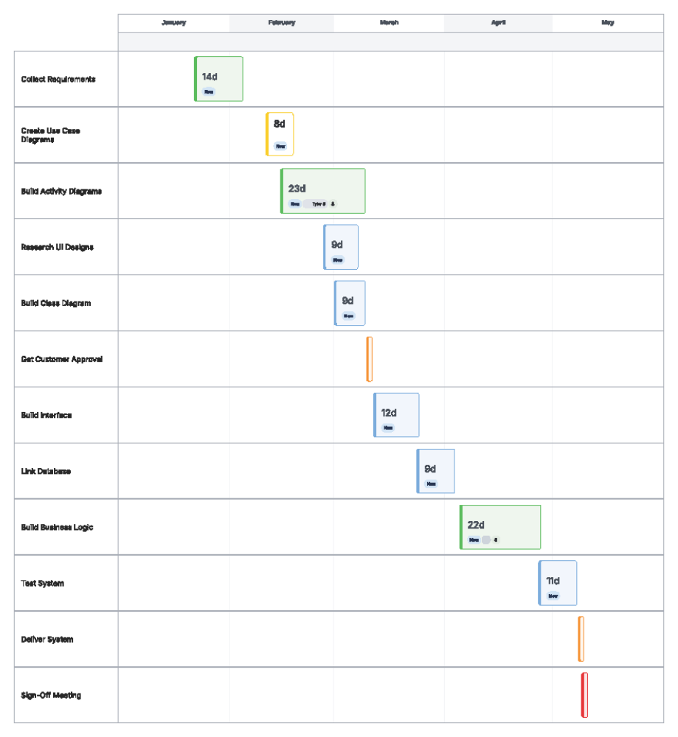

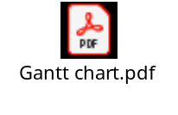
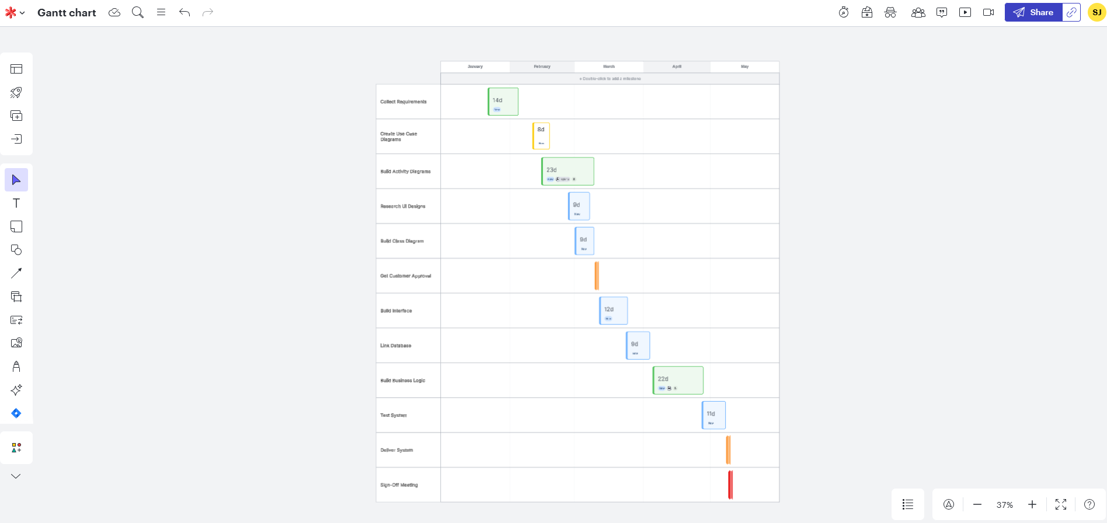
Screenshot from Lucid.

